

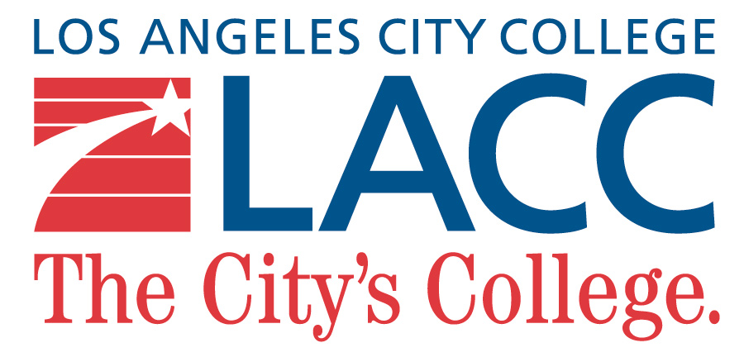

**INTERNATIONAL STUDENT ENROLLMENT GUIDEBOOK**

**Table of Contents**

**WELCOME**

**HOW TO APPLY TO ISP**

**IMMIGRATION INFORMATION FOR F1 STUDENT**

**SEVIS: STUDENT & EXCHANGE VISITOR INFORMATION SYSTEMS**

**TRAVEL & VISA**

**EMPLOYMENT**

**SEVERE ECONOMIC HARDSHIPS**

**SOCIAL SECURITY NUMBER**

**WHERE TO TURN TO FOR ANSWERS**

**ABOUT US**

**APPENDIX**

**CAMPUS MAP**

**EXPLANATION OF TERMS**

**Welcome to**

**Los Angeles City College**

The International Student Program (ISP) is designed to assist international students as they adjust to life in Los Angeles on an F-1 visa. We offer workshops and one on one meetings to help students understand federal immigration regulations and the benefits and restrictions of living in the United States on an F-1 visa.

For assistance please contact:

International Student Program: (323) 953-4000 ext. 2470

Marine Petrosyan (DSO): ext. 2470

Keika Stevenson (Counselor/Coordinator): ext. 2470

Annie Aghajanian (Secretary): ext. 2474

George Agoian (Counselor): ext. 2470 ext. 2471

**How to Apply to ISP**

An international student is someone applying to Los Angeles City College with an F-1 student visa issued by the U.S. Department of State (DOS). International students are not eligible for financial aids granted by the state of California nor the U.S. federal government.

**Admission Process and Required Documents**: The following information is to understand the admission process to Los Angeles City College as a full-time F-1 visa international student. Los Angeles City College is required by U.S. government regulations to collect and review the materials listed below to issue the immigration documents necessary to obtain a student visa. All documents submitted for evaluation will become the property of Los Angeles City College and will not be returned to the prospective student.

**Initial/New Student**

Students who are applying from abroad as a new F-1 visa student must submit the following documents:

* Step 1: Complete the CCC (California Community Colleges) application. NOTE: If you encounter an error message when you check the "No Expiration Date" under the I-94 information section on CCC Apply online application, please uncheck the "No Expiration Date" box and input any future date as an expiration date to move forward with your application submission. When selecting your Citizenship in Open CCCApply, select **"STUDENT VISA (F-1)"** regardless of your current status.
* Step 2: Complete the Supplemental Application Form [**F-1 Student Supplemental Application Form**](https://www.lacc.edu/sites/lacc.edu/files/2022-08/Supplemental-Application_Fillable-2021-22.pdf) (fillable PDF).
* Step 3: Complete the LACC (Los Angeles City College) international Student Agreement Form [**LACC International Student Agreement Form.**](https://www.lacc.edu/sites/lacc.edu/files/2024-05/LACC%20International%20Student%20Agreement_0.pdf)
* Step 4: Proof of Funds - Current proof of funding must be in the form of a bank letter or a bank statement (with an official signature/seal). All bank verifications should indicate U.S. currency and dated within 6 months of the term start date. An estimated yearly expense is $23,000 U.S. dollars.
* Step 5: [**Affidavit of Support Form**](https://www.lacc.edu/sites/lacc.edu/files/2022-08/Affidavit-of-Support-Form_Fillable.pdf) (If you have a financial sponsor).
* Step 6: Proof of English Proficiency (Duolingo test).
* Step 7: Copy of Transcripts or Equivalent, i.e., certificate of completion, diploma, etc. *Students under the age of 18 must provide proof of high school completion.
* Step 8: All the documents listed above must be emailed to [**iss@lacitycollege.edu**](mailto:iss@lacitycollege.edu) to be considered for admission as an F-1 student. (Please include your name in the "subject" of your email). We accept unofficial documents EXCEPT FOR FINANCIAL STATEMENTS.
* You must submit supporting documentation & $50 application fee. Click [**$50 Application Fee**](https://lacitycollege.flywire.com/) to send payment (non-refundable).

**Transfer Student**

Students who are currently in the United States on an F-1 visa and wish to transfer to Los Angeles City College must submit the following documents:

* [**F-1 Student Supplemental Application Form**](https://www.lacc.edu/sites/lacc.edu/files/2022-08/Supplemental-Application_Fillable-2021-22.pdf) (fillable PDF)
* [**LACC International Student Agreement Form**](https://www.lacc.edu/sites/lacc.edu/files/2024-05/LACC%20International%20Student%20Agreement_0.pdf)
* Proof of Funds - Current proof of funding must be in the form of a bank letter or a bank statement (with an official signature/seal). All bank verifications should indicate U.S. currency and dated within 6 months of the term start date. An estimated yearly expense is $23,000 U.S. dollars.
* [**Affidavit of Support Form**](https://www.lacc.edu/sites/lacc.edu/files/2022-08/Affidavit-of-Support-Form_Fillable.pdf) (If you have a financial sponsor)
* Proof of English Proficiency*
* Copy of Transcripts or Equivalent, i.e., certificate of completion, diploma, etc. *Students under the age of 18 must provide proof of high school completion.
* Copy of I-20 from current school
* Copy of Passport and Visa stamp
* [**Intent to Transfer-In Form**](https://www.lacc.edu/sites/lacc.edu/files/2022-08/Intent-to-Transfer-In-Form_Fillable.pdf)
* I-94 (if you are applying for Change of Status)
* All the documents listed above must be emailed to [**iss@lacitycollege.edu**](mailto:iss@lacitycollege.edu) to be considered for admission as an F-1 student. (Please include your name in the "subject" of your email). We accept unofficial documents EXCEPT FOR FINANCIAL STATEMENTS.
* You must submit supporting documentation & $50 application fee. Click [**$50 Application Fee**](https://lacitycollege.flywire.com/) to send payment (non-refundable).

**Immigration Information for F-1 students**

**What is F-1 Status**

In the United States the F visas are a type of non-immigrant student visas that allows foreigners to pursue education (academic studies and/or language training programs) in the United States. F-1 visas are only issued in U.S embassies and consulates outside the United States. Prospective F-1 students must apply to school and receive an I-20 form to apply for an F-1 visa. F-1 students must show they can support themselves during their stay in the U.S. as their opportunities for legal employment are limited. F-2 visas are given to dependents of an F-1 student, F-2 visa holders are prohibited from any form of compensated employment.

**Period of Authorized Stay**

Your admission to the U.S. is for “duration of status,” that is for the length of your F-1 status. F-1 status covers the period when you are a full-time registered student making normal progress toward your degree (or exchange programs), plus an optional period of practical training following completion of studies, plus a 60-days “grace period” to prepare to depart the U.S. or change to another status. Your length of authorized stay is not related to your F-1 visa expiration date. The F-1 visa is specifically for entry into the U.S. The F-1 visa might expire before your status expires, and your status might end before your visa expires.

**Document**

Federal Law requires that you carry registration documents. It is recommended that you keep copies of all your documents separate from your originals.

**Passport**

* Your passport must be valid for at least 6 months in the future.
* Passport renewal procedures vary depending on the country – typically, you may renew your passport 6 months prior to the expiration date.
* Contact your country's embassy in the US to determine the procedure for obtaining a new passport.

**Visa**

* After you received your Form I-20, you apply for an F-1 visa at a U.S. consulate.
* Your F-1 visa has an expiration date. If the VISA expires while you are in the U.S., it is not a problem.
* Travel outside the U.S. requires a valid visa to reenter the U.S.

**I-94**

If you arrived in the U.S. prior to April 26, 2013, you were issued an 11-digit ID number on a white card that was completed for you by the U.S. Customs official at port of entry. Your I-94 card is marked D/S (Duration of Status). Do not lose this card.

If you entered the U.S. after April 26,2013, your I-94 information is available to you through www.cbp.gov/I94

**I-20**

Your form I-20 was generated by SEVIS and issued by L.A. City College. It contains biographical data, indicates your program of study, describes the funding amount, and it contains your SEVIS ID number. The I-20 allows you to apply for an F-1 visa if you are outside the U.S., apply for F-1 status within the U.S., enter and reenter the U.S. in F-1 status and prove your eligibility for various F-1 benefits.

* You must ensure that your I-20 is valid, the program dates are current, and the program information is correct.
* We can extend your I-20 BEFORE it expires.
* We cannot extend your I-20 AFTER it expires.
* You may receive an email alert from the ISP before your I-20 expires.
* If your I-20 ends, your F-1 student status will terminate.

**Immigration Information for F-1 students**

**Events That Require an Update to Your I-20**

**Program Extension**

If you are unable to complete your course of study before the completion date noted in item 5 on your I-20, you must request an extended I-20 before your current I-20 expires. For more information and instructions, see Program Extension.

**Changing Schools**

You must register full time at LACC since the school issued you I-20 and overseas your SEVIS record. If you decide to transfer to another school, contact the international student office prior to completing your final semester at LACC.

**Change of Funding**

If there is a substantial change in the source of amount of your funding, report this change to the ISP office and a new I-20 will be issued to you. For example, if you receive an LACC scholarship through your department, but your I-20 indicates that you use personal funds to pay for expenses, you should request a new I-20

**Name Change**

The name on your I-20 should match the name on your passport. If you change any part of your legal name- first/given name, middle name, or last/family name- on your passport, this change should be reflected on you I-20. Conversely, if you want a different name on your I-20, the ISP will wait for you to change your passport first, before updating the I-20.

**Maintaining your Status**

F-1 students must enroll and complete full-time credit in the Fall and Spring semesters to maintain lawful immigration status.

ENROLL IN and COMPLETE the required number of units: Undergraduate Students 12 units.

There are limited reasons for under-enrollment. You must have permission from a DSO prior to under-enrollment.

**Exceptions to Full-Time Enrollment**

* Reduced Course Load (RCL) for specific Academic Reasons
* Reduced Course Load (RCL) for a Documented Medical Condition
* Final Semester
* Concurrent Enrollment

**About Full-Time Enrollment**

**Online Courses**

U.S. immigration regulations limit international students to only one online course (up to 3 units) per semester toward the minimum full-time enrollment requirement.

You can take more than one online course, but only one course (3 units) will meet your full-time enrollment requirements.

**Other Enrollment Issues**

* “I”-incomplete- or “N” - no credit assigned grades DO NOT count toward the full-time requirement
* Auditing a course does NOT count toward the full-time requirement
* Withdrawal from a course at ANY point in the semester does NOT count toward the full-time requirement.
* Courses that BEGIN in the middle of the semester do NOT count toward the full-time enrollment

**Employment in the US**

**On campus Employment**

USCIS allows F-1 students to work up to 20 hours per week on campus during the fall and spring semester without special permission. Employment must be on the LACC campus. F-1 students may work more than 20 hours per week on campus during school vacations (summer break, spring break, and fall break).

**F-2 Dependents**

Your spouse and unmarried child under 21 may be eligible for F-2 dependent status. Immigration regulations do not permit F-2 dependents to be employed in the US. The regulations also restrict full-time study for F-2 dependents with two exceptions:

* F-2 dependents CANNOT study full-time at LACC but may enroll in courses that are recreational in nature.
* An F-2 child may engage in fulltime study if the study is in an elementary or secondary school.

F-2 dependents must be approved for a change of status to F-1 by the USCIS prior to commencing full-time study at LACC. Applications take 6-8 months.

**Change of Address Procedure**

F-1 students in the United States are required by law to notify their school/DSO of any address change **within 10 days (about 1 and a half weeks)** of the change.

**Travel**

* Travel within the US does not require a travel signature from DSO.
* Travel outside the US requires that your I –20 be signed for travel by DSO.
* Visa expired? You must apply for and receive a new visa before re-reentering the U.S.
* We recommend you carry clear copies of your immigration documents if you travel to US border areas or large metropolitan areas. For more information see travel.

**Termination and Reinstatement**

* A violation of status will result in a termination of your F-1 status.
* Students whose F-1 status is terminated may qualify for a Reinstatement of Status.
* You must apply directly to USCIS requesting reinstatement back into F-1 status.
* This option is not available for all violations, notably employment violations.

**Graduation or Program Completion**

The end of your academic program affects your F-1 status. After you graduate or complete your program you have a 60-day grace period. Within this 60-day period you have the following options:

Depart the U.S. Once you leave the U.S. (including trips to Canada and Mexico) after completing your studies you are not eligible to reenter with your current 1-20. The grace period is meant for travel within the states and preparation to depart the U.S.

Request a new I-20 if you will continue at LACC in a new degree program.

Transfer your SEVIS record to a new school.

Apply to change status to another visa category. LACC DSO advisors cannot assist with change of status applications. If you need additional assistance, we recommend you contact an immigration attorney.

**SEVIS: STUDENT AND EXCHANGE VISITOR INFORMATION SYSTEM**

**Overview**

**SEVIS** reports the following information to USCIS (United States Citizenship and Immigration Services) and ICE (Immigration and Customs Enforcement):

**Personal Address Information**

**Financial Information** –education funding

**Academic Program Information** –fulltime/ part time enrollment, major changes, disciplinary actions, extension of program

**Employment Information:** optional/curricular practical training, off campus employment authorization

**Termination or Completion of Study**

**Dependent information**

It is important to understand the F-1 immigration regulations to maintain status while you are in the U.S.

**Travel & Visa**

**Re-entry into the U.S.**

Be prepared to present the following materials at the port of entry into the U.S.

* I-20 and Travel Signature from the DSO (F-1 student)
* Passport –valid at least six months into the future
* Valid F-1 visa stamp is passport
* Evidence of Financial Support (bank statement, scholarship/assistantship letter)
* Proof of enrollment (transcript and computer printout of current enrollment and next semesters enrollment if available)

**I-20 Travel Signature**

Page 2 of your **1-20 must be signed by a Designated School Official** before you leave the US. This signature will be **valid for one year (12 months)** and can be used for multiple entries. If you are on OPT, you must obtain a travel signature every 6 months.

To obtain a travel signature, **submit your travel authorization signature request to the ISP office.** Your I-20 will be available for pick in 2-3 business days. We need 2-3 business days to process the travel signature, so please plan before you travel.

**Valid Passport**

Your Passport must be valid for at least six months when seeking admissions and readmission to the United States unless your country has an agreement with the United States. For a list of countries under this agreement, see the list on the Immigration Customs Enforcement website. Your passport should remain valid throughout your stay in the U.S.

**Valid Visa**

You must present a valid unexpired visa in the category for which admission is being sought each time you enter the U.S. (Canadian citizens are exempt from the visa requirement; however, landed immigrants of Canada are generally required to obtain a visa.) If your visa expires while you are in the U.S., the next time you travel abroad you must obtain a new visa in the proper category to be readmitted to the United States. Apply for the visa in your home country unless circumstances or travel plans make this impossible. If you apply for a visa at a U.S. consulate in another country, your application may be reviewed more critically than if you applied at home. In-person interviews are required for most visa applicants. You are encouraged to contact the U.S. consulate as early as possible to schedule the visa interview appointment. Anticipate delays in visa issuance due to enhanced security reviews.

**Automatic Visa Revalidations**

An exception to the rule requiring a valid unexpired visa exists for students inF-1 and J-1 status who travel for less than 30 days (about 4 and a half weeks) solely to Canada or Mexico or islands in the Caribbean except Cuba. Your visa will be considered “extended” (and “converted” to the proper visa category if you had changed status while in the U.S.) to the date of reentry, eliminating the need to obtain a new visa at a U.S. consulate before that re-entry.

Note that if you apply for a new visa while in Canada, Mexico, and islands in the Caribbean, you will not be able to return to the U.S. unless the visa is granted. Also, citizens of Iraq, Iran, Syria, Libya, Cuba, Sudan, and North Korea are not eligible for automatic visa revalidation.

**Travel**  **Within the US**

If you are traveling within the U.S., it is recommended that you carry the following items:

* Passport
* Valid I-20
* I –94 number

**Entry into Another Country**

Before you leave the United States, contact the consulate of the country to be visited to inquire about visa and travel procedures. If you plan to visit Canada, contact the Canadian Consulate in Los Angeles to determine if you need a visa to enter Canada.

**Travel after completion of studies**

If you travel outside the U.S. after completion of studies, you may return to the U.S. in F-1 status provided you are in possession of:

* A new I-20 indicating a new program of study, passport, visa, and evidence of financial support.

OR

* An Employment Authorization Document (EAD), I-20 endorsed for OPT and signed for travel within the last six months, proof of employment/employment verification letter.

**Travel and OPT**

If your pre-completion OPT application is pending or approved, you may travel and reenter the U.S.

If your post-completion OPT application is pending, you may travel and re-enter the U.S.

After graduation, if you post completion OPT has been approved and your EAD issued, you may not re-enter the U.S. unless you have evidence of employment. You should carry the following documents with you:

I-20 signed for travel by an international student advisor within the **last 6 months.**

EAD card

Valid Passport

Unexpired F-1 visa (unless returning from a short trip to Canada, Mexico, or the Caribbean)

Evidence of employment in your field of study (letter of employment, written job offers)

**What Is a Visa?**

The F-1 visa stamp in your passport is permission to apply to enter the United States in the Visa Category. Although your passport and I-20 must remain valid while you are in the U.S., your visa need not remain valid once you have used it to enter the U.S. and/or its number of entries has been used or if you have changed your nonimmigrant status while in the U.S. The next time you travel abroad you must obtain a new visa in the proper category to be readmitted to the U.S. Visas can only be obtained outside of the U.S. at a U.S. consulate (Canadian citizens are not required to have a visa stamp to enter the U.S.)

**Automatic Visa Revalidations**

An exception to the rule requiring a valid unexpired visa exists for students in F-1 status who travel for less than 30 days (about 4 and a half weeks) solely to Canada or Mexico or islands in the Caribbean except Cuba. Your visa will be considered “extended” (and “converted” to the proper visa category if you had changed status while in the U.S.) to the date of reentry, eliminating the need to obtain a new visa at a U.S. consulate before that re-entry.

Note that if you apply for a new visa while in Canada, Mexico, and islands in the Caribbean, you will not be able to return to the U.S. unless the visa is granted. Also, citizens of Iraq, Iran, Syria, Libya, Cuba, Sudan, and North Korea are not eligible for automatic visa revalidation.

**How, Where and When to Apply for a Visa**

Apply for the visa at a U.S. consulate in your home country unless circumstances or travel plans make this impossible. It may be possible to apply for a visa at a US consulate in a country other than your home country. This a called a “third country national (TCN)” application. Not all U.S. consulates accept TCN applications, and some allow TCN applications for limited situations; check with individual consulates, including those in Canada and Mexico, for TCN application policies. It can be risky to apply in a country other than your home country. For instance, if you apply for a new visa in Canada and encounter delays, you must remain in Canada for the length of the processing. You will not be able to reenter the US until the new visa is approved.

U.S. consulates require in-person interviews for most visa applicants. You are encouraged to schedule the visa interview appointment as early as possible. The U.S. Department of State maintains an excellent website on the visa application process, and you should study it carefully. You can also find information about how long it will take to get your visa. Students applying for initial-entry F-1 and F-2 visas may be issued visas up to 120 days (about 4 months) before the academic program start date as noted on the I-20.

Visa processing delays may occur due to enhanced security reviews that consider your field of study, country of origin and likelihood of returning home after completion of studies.

* **Visa Application:** Complete the form provided by the U.S. consulate in the country where the application will be submitted. You will be charged a fee for the visa application.
* **Receipt** confirming payment of the I-901 SEVIS fee, if applicable.
* **Valid Passport:** Your Passport must be valid for at least six months when seeking admissions and readmission to the United States unless your country has an agreement with the United States. For a list of countries under this agreement, see the list on the Immigration Customs Enforcement website. Your passport should remain valid throughout your stay in the U.S.
* **Passport Size Photo**
* **I-20:** If you are applying for a visa to continue studies at LACC, be sure that a DSO has signed the travel validation section of the form within the past year. (Newly admitted students do not need a travel signature for the initial visa interview.)
* **Financial Evidence** detailing sources and amount of funding. Consular and immigration officers exercise considerable discretion in determining whether financial support exists and is sufficient to cover your entire period of stay. Prepare documentation that is thorough, consistent, credible, and varied.
* **Official Academic transcript and confirmation of enrollment.** You can request these documents from the Admissions and Records office. **(If you are newly admitted student, you should provide proof of admission to LACC ISP)**
* **Proof of English language proficiency** may also be requested.
* **Evidence of continuing ties** (such as family, career, or property) to your home country. Visa applicants are presumed to be “intending immigrants.” Your visa will be denied unless you satisfy the consular officer that you will return home. Unfortunately, there is no single explanation, document, or letter that can guarantee visa issuance.
* Consular officers conduct quick interviews! Their initial impression of you is critical to your success. Keep your answers concise. Be honest in everything you write on your visa application and say during the interview. Anticipate that the interview will be conducted in English. Do not bring other people to speak on your behalf.
* Be able to explain the reasons you want to study in the U.S. and remember that your main reason for coming to the United States is to study, not to work!
* If your spouse and children are remaining behind in your home country, be prepared to explain how they will support themselves in your absence. If they are accompanying you to the U.S., be prepared to show proof of adequate funding.
* If you are denied the visa, ask the officer for a list of documents he or she would suggest you bring the next time you apply, and try to get the reason you were denied in writing. Maintain a positive attitude!

**Employment**

This section contains information about F-1 student employment options,

Including how to obtain a Social Security number.

* On-Campus Employment
* CPT
* OPT
* Severe Economic Hardship
* Social Security Number

**On Campus Employment**

**Overview**

Your F-1 student status permits you to work on the campus of the school that issued your current I-20. You must successfully complete one semester with 12 units before you are eligible to work on campus. While working on campus you are required to maintain your status (except for approved exceptions) and be in good academic standing. Employment must be on LACC campus.

**Time Period**

* F-1 Students can work up to 20 hours per week on campus during the fall and spring semester.
* F-1 students may work more than 20 hours per week on campus during school vacations (summer break, spring break, and fall break).

**Expiration of On-Campus Employment Eligibility**

Your on-campus employment eligibility ends:

* When you graduate
* If you transfer to another college: your work authorization expires on the day of your SEVIS record release date.
* If you violate your F-1 status

**Obtaining Employment**

Contact the LACC Career Center for available job opportunities on campus.

1. Obtain a **Letter of Employment** from your hiring supervisor.
2. Submit the **Letter of Employment** to your designated DSO. Employment start date cannot be more than 30 days (about 4 and a half weeks) in the future.
3. Obtain the **Social Security Letter** from your DSO. Only the Designated School Official at LACC ISP can write this letter after receipt of the letter of employment. It certifies that the student is enrolled full-time and holds a valid F-1 status.
4. Bring the following documents to the Social Security Office:

* Original I-20
* Passport with printed I-94 and Visa
* Employment Letter from Employer(F-1)
* Original Social Security Letter from DSO
* From DSO SS-5 (Social Security Number Application)

1. Once a Social Security Number has been issued, **On-Campus Employees** should bring the following documents to the employer along with:

* SSN Card
* Original passport with U.S. visa

**Curricular Practical Training**

**CPT Overview**

Curricular Practical Training (CPT) is an off-campus employment option available to F-1 students when the training (i.e., internship or employment) is considered an integral part of the established curriculum and related to the student’s major. “Training” refers to paid or unpaid work/study experience, internships, or cooperative education.

**Time**

CPT can only be used during a student's program of study.

CPT approved for part-time (20h or less per week) or full-time (21h or more per week). Full-time CPT granted for summer semester only.

* Students who use 12 full months of full time CPT become ineligible for OPT under US immigration law.
* Use of part-time CPT does not affect OPT.
* Consider applying for pre-completion OPT if your degree program is not eligible for CPT.

**Eligibility**

You are eligible for CPT if:

* Lawfully enrolled as a full-time student for one full academic year (fall + spring semester).
* You will earn your degree from LACC.

Other Requirements

* Must have an employment/training offer related to your major area of study.
* Students authorized for part-time CPT (20h or less per week) must be enrolled full-time (in 12 units) each semester they engage in CPT.
* Students who have completed their program requirements and are merely delaying graduation to make use of CPT are not eligible.

**CPT Employment Duration & Limitations**

* Approval granted each semester
* You must reapply prior to each semester if interning multiple semesters
* Not permitted to work until you receive an I-20 authorizing specific CPT dates
* Approved for a specific employer and a specific period

**Application Procedures**

* Attend CPT workshop
* Meet with your Department Chair and/or instructor; request that s/he complete the CPT Authorization Request Form
* Obtain detailed internship offer letter
* Submit application to your DSO
* DO NOT START THE INTERNSHIP BEFORE YOU ARE AUTHORIZED FOR CPT!

**Optional Practical Training**

**OPT Overview**

Optional Practical Training (OPT) is work authorization available to international students who have been in valid F-1 status for at least two consecutive semesters and who plan to seek employment in the U.S. in their field of study. Temporary employment authorization is granted by the U.S. Citizenship and Immigration Service (USCIS).

OPT can be taken during annual summer vacation, part-time during regular school session, after completion of course requirements or after completion of course of study.

**Pre-Completion OPT**

* Pre-Completion OPT is temporary employment available to F-1 students prior to completion of the course of study (i.e., prior to the program and date on the I-20).
* The employment must be related to the student's field of study and commensurate with the student’s education level.
* A student may be eligible for up to 12 months of OPT per degree level.
* A student will become eligible for another 12 months of OPT when he/she completes a higher education level.
* A student must receive an EAD card from the USCIS Service Center and the start date on the EAD card must arrive before they may begin their OPT employment.

**Post-Completion OPT**

Post-Completion OPT is temporary employment available to F-1 students following completion of the course of study (i.e., after the program and date on the I-20).

The employment must be related to the student's field of study and commensurate with the student’s education level.

* A student may be eligible for up to 12 months of OPT per degree level.
* A student will become eligible for another 12 months of OPT when he/she completes a higher education level.
* A student must receive an EAD card from the USCIS Service Center and the start date on the EAD card must arrive before they may begin their OPT employment.

**How Does Pre-Completion OPT differ from Post–Completion OPT**

* Pre-Completion OPT occurs before the I-20 program end date. ISP will not shorten the I-20 program and date.
* Days of unemployment do not accrue during Pre-Completion OPT.
* A student may not be able to work full-time.
* If a student does not graduate by the program end date on their I-20, the student may request a program/I-20 extension.
* Students are not eligible to apply for the STEM (Science, Technology, Engineering and Mathematics) OPT Extension.
* Students are not eligible for the H-1B CAP GAP fix.

**Time Period**

During OPT, a student continues in F-1 status since OPT is considered part of the program of study.

**Pre-OPT:**

* A student who still has coursework remaining to complete his/her educational objectives or degree program is limited to 20 hours per week of Pre-Completion OPT during the Fall and Spring semesters.
* All students may apply for full-time Pre-Completion during annual vacation (summer) and other official school breaks.

**Post OPT:**

* A student may work full-time while on post-OPT.
* For OPT purposes, your completion date is the day you complete your final degree requirements. Your completion date is considered the last day of final exams of the semester if your degree requirements are fulfilled.
* You are allowed a 60-day grace period following your OPT expiration date to leave the U.S., change your status, or transfer your F-1 to a new school or program. Please keep your address information updated during this period as well (you are not allowed to work during the grace period).

**Eligibility**

You are eligible for Pre-OPT if:

* An F-1 student who has completed full-time enrollment for at least one Fall and one Spring semester or who is within 90 days (about 3 months) of doing so.
* Students who work full-time for 12 months or more on Curricular Practical Training (CPT) are not eligible for OPT.

You are eligible for Post-completion OPT if:

* You may apply to participate in post-completion OPT after you have been lawfully enrolled on a full-time basis for one full academic year and completed all your degree program requirements.
* One year of OPT is available after completing each higher-level degree program.

**Employment**

* A job offer is not required to apply for OPT. However, once you find a qualifying job, you must notify your DSO Office.
* Unemployment is allowed for no more than 90 days (about 3 months).
* For Post-OPT the employment may occur anywhere in the U.S.
* No special permission is required to change employers or terminate your employment. However, you must notify your DSO of your unemployment and/or new employers' information using the OPT Reporting Form.
* Once you complete your degree, you cannot work on-campus or off-campus until you have the EAD in your possession and your chosen start date has arrived.

Employment may include:

**You should be employed at least 20 hours per week. Regardless of your job title or how the position is classified, such as an “intern,” “temp,” “freelance contractor,” “post-doc,” etc., the following employment options are allowed:**

* **Multiple employers:** You may work in your field of study for more than one employer.
* **Work for hire:** Contract employment in your field of study
* **Self-employment:** You may start a business and be self-employed in your field of study. You must have a business license and document your active engagement in business related to your degree.
* **Employment in your field of study through an agency or consulting firm.**
* **Volunteer Service: You may work as a volunteer or unpaid intern in your field of study if this does not violate labor laws.**

**Travel & OPT**

**Pre-OPT**

If your pre-completion OPT application is pending or approved, you may travel and reenter the U.S. (However, please note that the USCIS sometimes sends a request for more information or for you to correct a problem with your documentation. These requests are sent by postal mail, so it might be difficult for you to respond if you are not inside the U.S. It is your application, so LACC does not have the authority to respond for you.)

**Post-OPT**

If your post- completion OPT application is pending, you may travel and re-enter the U.S.

After graduation, if your post-completion OPT has been approved and your EAD issued, you may not re-enter the U.S. unless you have evidence of employment. You should carry the following documents with you.

* I-20 signed for travel by an international student advisor within the last 6 months
* EAD Card
* Valid Passport
* Unexpired F-1 visa (unless you are Canadian or are returning from a short trip to Canada, Mexico, or the Caribbean).
* Evidence of employment in your field of study (letter of employment, written job offers).

*On the EAD card, there is a statement “Not Valid for Reentry” which means that the EAD card alone is not a proof of your legal status to seek entry into the U.S. You must have all the documents mentioned above to be able to reenter the country.

Once the approved period of OPT has begun, time spent outside the U.S. will count as unemployment against the 90-day limits. However, travel while employed either during vacation authorized by an employer or as part of your employment will not count as unemployment. Please keep your DSO informed of any travel plans while on OPT that may affect your status.

If you have dependents in F-2 status who will travel without you, be sure they carry a photocopy of your EAD card and proof of your employment along with their updated F-2 I-20 that is properly signed for travel.

**Study While on OPT**

While Approved for OPT you may take recreational courses, but if you begin a new degree program, your OPT is automatically terminated.

**After your Post-OPT Ends**

Students who do not exceed 90 days (about 3 months) of unemployment and report employment to ISP as required are automatically granted a 60-day grace period after the end date listed on the EAD (Employment Authorization Document). Within this 60-day grace period, you have the following options:

* Depart the U.S. Once you leave the U.S. (including trips to Canada and Mexico) after completing your studies and OPT period, you are not eligible to reenter with your current I-20. The grace period is meant for travel within the states and preparation to depart the U.S.
* Request a new I-20 if you will continue at LACC in a new degree program.
* Transfer your SEVIS record to a new school.
* Apply to change status to another visa category.

**Application Deadlines**

* It can take the USCIS three to five months to issue the Employment Authorization Document (EAD) that allows you to begin working on OPT.
* Once the OPT application is submitted to the USCIS, it is difficult to change or cancel the application.

**Pre-OPT**

F-1 students can apply for pre-completion Optional Practical Training (OPT) up to 90 days (about 3 months) before completing a full academic year in the United States if the requested start date is after the academic year.

**Post-OPT**

The earlier you can apply for OPT is 90 days (about 3 months) before your program completion date. The latest date USCIS will accept your applications 60 days (about 2 months) after your program completion date. In addition, OPT applications must be submitted to USCIS within 30 days (about 4 and a half weeks) or receiving an OPT I-20 from the ISP office.

**Application Procedure**

* Attend an OPT workshop
* Complete and submit an OPT Request Form to the ISP office
* Complete form I-765
* Check or money order payable to “U.S. Department of Homeland Security” for $470.00
* Photocopies of Form I-94 front and back.
* Photocopies of all prior I-20 forms
* Picture ID: 1) Photocopy of your last EAD (front and back) or, 2) Federal Government issued identity document, such as a **passport; visa** issued by a foreign consulate
* 2 color photos on white background (The photos should be approximately 2” x 2”. Write your name and I-94 number on the back of each photo in case they get separated from your application.)
* Obtain a new I-20 from the ISP office
* You may file your OPT application online at [www.uscis.gov](http://www.uscis.gov) or you can mail your application to USCIS. It is **YOUR** responsibility to mail applications and supporting documents to USCIS. Mail your application to:

|  |  |
| --- | --- |
| **U.S. Postal Service (USPS)** USCIS Attn: I-765 C03 P.O. Box 805373 Chicago, IL 60680-5374 | **FedEx, UPS, and DHL deliveries:**  USCIS Attn: I-765 C03 (Box 805373) 131 South Dearborn - 3rd Floor Chicago, IL 60603-5517 |

**Severe Economic Hardship**

**Overview**

If you are suffering a severe economic hardship due to unforeseen changes in your financial circumstances, you may apply to the United States Citizenship and Immigration Services (USCIS) for authorization to work off-campus. You must have been in F-1 status for one academic year, be in good academic standing, and document that on-campus employment opportunities are unavailable or insufficient to meet your financial needs. Examples of unforeseen circumstances include loss of financial support or on campus employment, substantial fluctuations in the value of currency or exchange rate, inordinate increase in tuition and/or living costs, unexpected change in the financial conditions of your source of support, medical bills, or other substantial and unexpected expenses,

Contact a DSO to discuss your situation before you complete the required documentation. Your advisor will determine your eligibility. If eligible, you will receive an I-20 with off campus employment recommendation to file for the work authorization with USCIS.

Application processing times vary between two to four months. If approved, USCIS will issue an Employment Authorization Document (EAD) for a maximum of one year. Do not begin working until you receive the EAD. If approved, you may work for any employer up to 20 hours per week while enrolled in a full course of study and full-time during quarter breaks and your annual vacation quarter. This employment does not affect your eligibility for Optional Practical Training (OPT).

**Social Security Number**

**Overview**

A Social Security Number is issued to track earnings over a worker’s lifetime. Students holding F-1 status and are employed in the U.S. must apply for a Social Security Number.

Only students who have an official employment offer can apply for a Social Security Number.

All LACC student employees must apply for a Social Security Number (SSN) BEFORE reporting to the Hiring Personnel for Payroll processing.

**Application Procedure**

**F-1 Students with On-campus Work:**

1. Obtain a Letter of Employment from your hiring supervisor.
2. Submit the **Letter** to the DSO in the ISP Office for the Employment start date cannot be more than 30 days (about 4 and a half weeks) in the future. The Employment Letter must be dated within the last 30 days (about 4 and a half weeks).
3. Obtain the Social Security Letter from your designated DSO. Only the Designated School Official at LACC can write this letter after receipt of the Letter of Employment. It certifies that the student is enrolled full time and holds a valid F-1 status
4. Bring the following documents to the Social Security Office:

* Original I-20
* Passport with printed I-94 and Visa
* Employment Letter from Employer (F-1)
* Original Social Security Letter from your DSO
* Form SS-5 (Social Security Number Application)

Once a social security number has been issued, On-Campus Employees should bring the following documents to their supervisor to complete payroll signup forms.

* SSN Card
* Original Passport with U.S. visa

**F-1 Students Authorized for CPT**

1. Form I-20 updated and endorsed for CPT
2. Passport
3. I-94 printout
4. Form SS-5

**F-1 Students Authorized for OPT**

1. Form I-20 endorsed for practical training
2. Passport
3. I-94 printout
4. EAD Card
5. Form SS-5

**Location**

**Social Security Administration**

* 1122 Vine St,
* Los Angeles, CA 90038
* Call: (800)325-0778

**WHERE TO TURN FOR ANSWERS**

If you need help with: ￼

Contact:

* International Academic Counselor
* Professor teaching that course
* Welcome Center
* Health &Wellness Center
* Health & Wellness Counselor/International Student Advisor
* Designated DSO
* LACC Class Schedule
* International Academic Counselor
* Trouble with your Professor
* Trouble with your English
* Details about a specific course
* Late assignments
* Cannot understand the lecture
* Student Activities
* Photo ID Cards
* Medical Problems

* Personal or Adjustment problems
* Visa or I-20 Problems
* Schedule of Courses
* Graduation Questions
* Field of Study (Major)

**About Us**

1. You are a new student seeking to attend LACC
2. Change of Status Advisement
3. You are a new student seeking to Transfer-in to LACC
4. Academic and Immigration Advising
5. Academic Issue (Probation & DQ)
6. Approval of Benefits
7. Approval to Attend Part-time
8. Concurrent Enrollment
9. Change of Address forms/reporting
10. Driver's License information
11. Extension of Program
12. New Student Check in
13. Passport or Visa Questions
14. Severe Economic Hardship
15. Transfer-out Requests
16. Travel Signatures
17. Curricular Practical Training
18. On-Campus Employment
19. Optional Practical Training
20. Social Security Guidelines
21. Reinstatement Advising
22. Travel Study or Mobility/Exchange
23. Travel Signatures
24. Cultural Adjustment Advising
25. Information on events and workshops
26. Questions regarding Student Health Insurance
27. Computers and Study Areas
28. Find more friends and practice English
29. Meet the staff!

**Available DSO**

* Marine Petrosyan
* George Agoian

**Available Directors**

Darren Grosch- Associate Dean of Academic Affairs and International Student program

**Hours of Operation, Location & Contact**

**International Student Program**

Los Angeles City College

Cesar Chavez Administration Building AD-109

855 N. Vermont Avenue

Los Angeles, CA 90029

Tel: (323) 953-4000

Fax: (323) 953-4013

Email: iss@lacitycollege.edu

Monday- Thursday: 9:00am-4:00pm

Friday: 9:00am-3:00pm

Mailing Addresses

Los Angeles City College

International Student Program

Cesar Chavez Administration Building AD-109

855 N, Vermont Avenue

Los Angeles, CA 90029

**Appendix**

**WEBLINKS**

**Los Angeles City College:**

<https://www.lacc.edu/>

**LACC Student Portal:**

<https://sso.laccd.edu/adfs/ls/idpinitiatedsignon.aspx?loginToRp=csprd.laccd.edu>

**International Student Program:**

<https://www.lacc.edu/student-services/spr/international>

**State of Department and Government Links**

**US State Department:**

<https://travel.state.gov/content/travel.html>

**Visa Bulletin:**

<https://travel.state.gov/content/travel/en/us-visas.html>

**Home page US Department of State**

<https://www.state.gov/>

**Social Security Online:**

<https://www.ssa.gov/>

**Social Security for Noncitizens:**

<https://www.ssa.gov/pubs/EN-05-10096.pdf>

**US Citizenship & Immigration Services:**

<https://www.uscis.gov/>

**Embassies and Consulates**

<https://travel.state.gov/content/travel/en/us-visas/visa-information-resources/list-of-posts.html>

**Internal Revenue Service and Taxes**

**US IRS**

<https://www.irs.gov/>

**Forms and Publications**

<https://www.irs.gov/forms-instructions>

**Lawyers**

**American Immigration Lawyers Association:**

<https://www.aila.org/>

**Resources**

**Cultural Adjustment and transitioning:**

<https://www.internationalstudent.com/study_usa/>

**NAFSA**

<https://www.nafsa.org/>

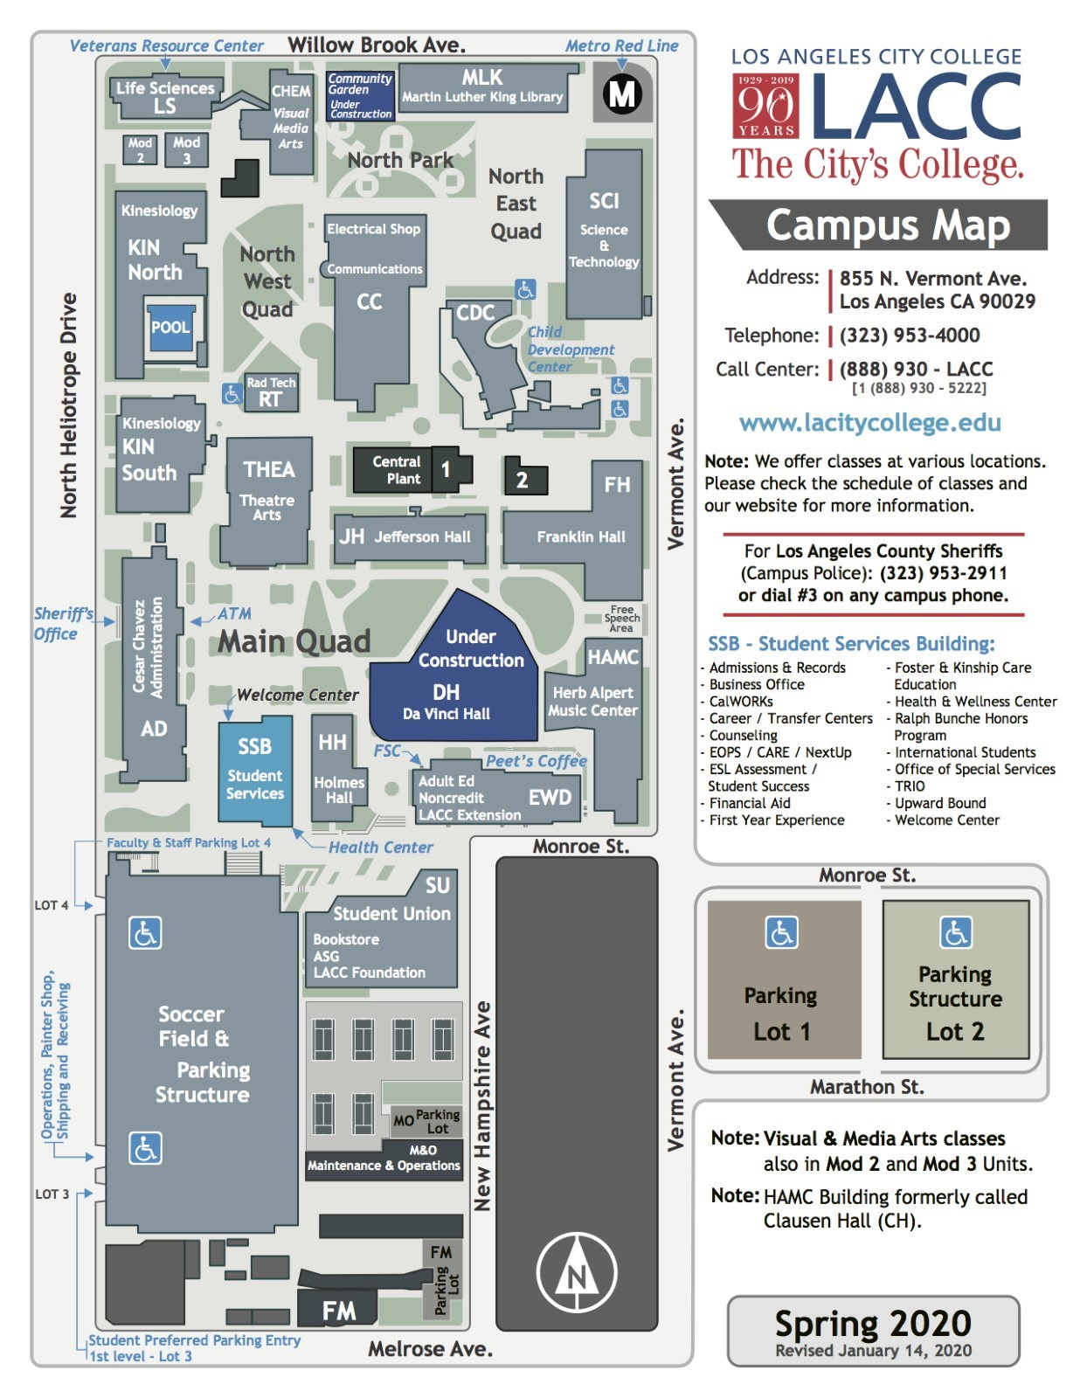

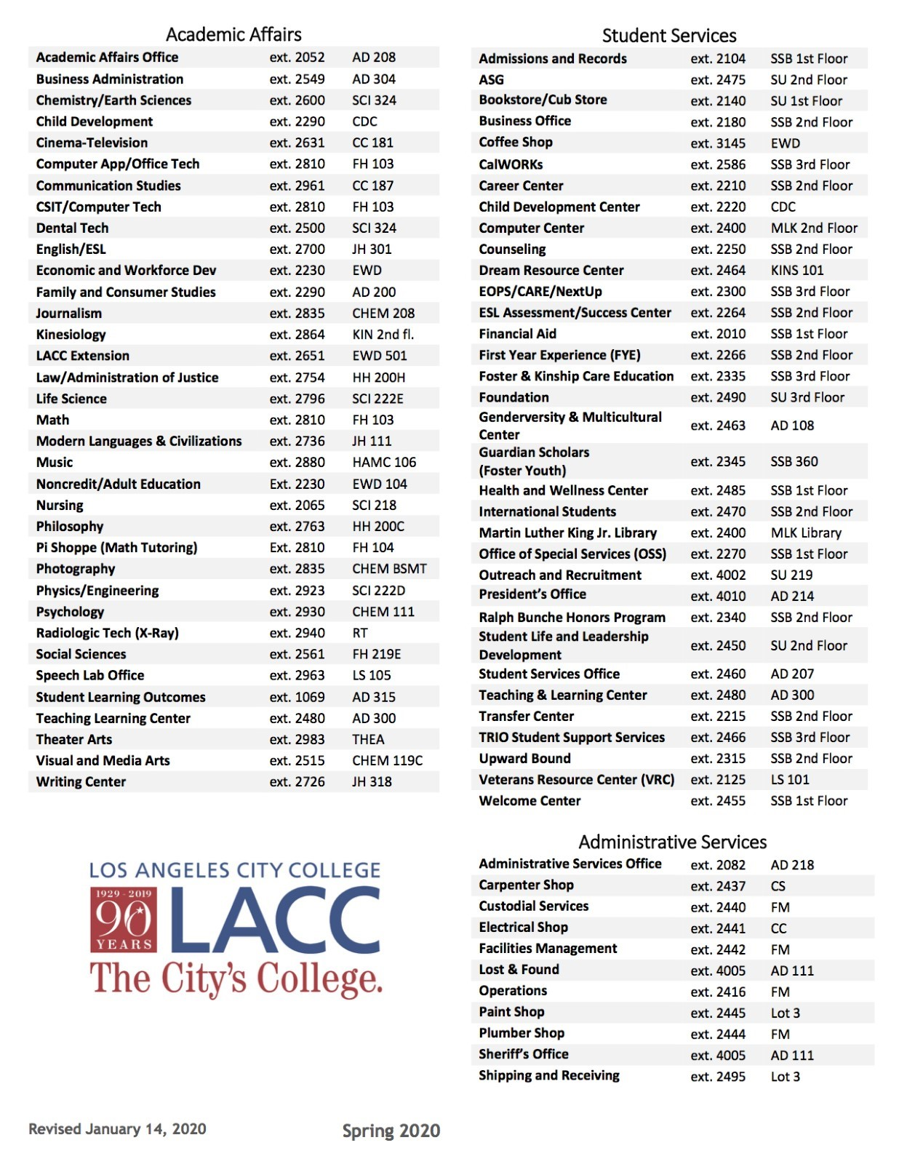

**Explanation Of Terms**

**Lawful Status:** Legal presences inside the United States; following (complying with) the rules and regulations on page 3 of your I-20 to stay in school in the U.S.

**Out of Status:** Breaking the rules or regulations mentioned above.

**USCIS-United States Citizenship and Immigration Service:** The division of the U.S. government which monitors your activities while you are studying here.

**Withdraw:** To drop out of class; to stop attending a course before the end of the semester.

**Notify:** To give notice, to alert or advise.

**Reinstatement:** The process of filing paperwork to ask the United States Citizenship and Immigration Services (USCIS) to permit you to return to classes after you have fallen **OUT OF STATUS.**

**GPA (Grade Point Average):** Calculations of the sum of your grade points. A=4 points, B=3 points, C=2 points, D=1 point, F=0 points. To find your average, you multiply the number of units by the grade points (example: 4 units x 3 points (B Grade) =12 points). Do this for each grade you receive. Then you divide your grade point by the number of units you have attempted. This sum is your GPA for the semester. There are examples in the catalog for you to follow.

**Academic Probation:** This is the school’s warning that you are in danger of being dismissed from the school.

**OPT (Optional Practical Training):** Is a period during which undergraduate students with F-1 status who have completed their degree are permitted by the USCIS to work up to one year on a student visa without needing to acquire a work visa towards getting a practical training to complement their field of studies.

**DSO (Designated School Official):** SEVP- certified official who can communicate with SEVP update student records in SEVIS and help you maintain your student status by providing advice or assisting you with filing out important forms.

